**Защита лабораторной работы №2**

**Листинг программы:**

#include "mainwindow.h"

#include "ui_mainwindow.h"

#include <QMessageBox>

MainWindow::MainWindow(QWidget *parent)

: QMainWindow(parent)

, ui(new Ui::MainWindow)

{

ui->setupUi(this);

}

MainWindow::~MainWindow()

{

delete ui;

}

QString sloj(QString per1, QString per2){

int length1 = per1.length();

int length2 = per2.length();

int maxlength;

int perenos = 0;

QString otvet = "";

if (per1.length()>per2.length()){

maxlength = per1.length();

for (int i=0;i<length1-length2;i++)

per2="0"+per2;

}

else if (per1.length()<per2.length()){

maxlength = per2.length();

for (int i=0;i<length2-length1;i++)

per1="0"+per1;

}

else{

maxlength = per2.length();

}

for (int i=maxlength-1;i>=0;i--)

{

if (per1[i].unicode()+per2[i].unicode()==96){

if (perenos>0){

otvet = '1' + otvet;

perenos--;

}

else {

otvet = '0' + otvet;

}

}

else if (per1[i].unicode()+per2[i].unicode()==97){

if (perenos>0){

otvet = '0' + otvet;

}

else{

otvet = '1' + otvet;

}

}

else if (per1[i].unicode()+per2[i].unicode()==98){

otvet = '0' + otvet;

perenos++;

}

//QMessageBox::warning(this, "Внимание",QString("%1").arg(per1[i].unicode()+per2[i].unicode())+" "+per1[i]+" "+per2[i]);

}

if (perenos>0){

otvet = '1' + otvet;

}

return otvet;

}

QString vich(QString per1, QString per2){

int length1 = per1.length();

int length2 = per2.length();

int maxlength;

int perenos = 0;

QString otvet = "";

if (per1.length()>per2.length()){

maxlength = per1.length();

for (int i=0;i<length1-length2;i++)

per2="0"+per2;

}

else if (per1.length()<per2.length()){

maxlength = per2.length();

for (int i=0;i<length2-length1;i++)

per1="0"+per1;

}

else{

maxlength = per2.length();

}

for (int i=maxlength-1;i>=0;i--)

{

if (per1[i].unicode()-per2[i].unicode()==1){

if (perenos==0){

otvet = '1' + otvet;

}

else{

otvet = '0' + otvet;

perenos--;

}

}

else if (per1[i].unicode()-per2[i].unicode()==0){

otvet = '0' + otvet;

}

else if (per1[i].unicode()-per2[i].unicode()<0){

otvet = '1' + otvet;

perenos++;

}

//QMessageBox::warning(this, "Внимание",QString("%1").arg(per1[i].unicode()-per2[i].unicode())+" "+per1[i]+" "+per2[i]);

}

if (perenos>0){

otvet = '-' + otvet;

}

return otvet;

}

void MainWindow::on_pushButton_clicked()

{

if (ui->checkBox->isChecked()){

QString per1 = ui->ch1->text();

QString per2 = ui->ch2->text();

ui->result->setText(sloj(per1, per2));

}

else {

float vrem;

vrem = ui->ch1->text().toFloat()+ui->ch2->text().toFloat();

QString str;

str.setNum(vrem);

ui->result->setText(str);

}

}

void MainWindow::on_pushButton_2_clicked()

{

if (ui->checkBox->isChecked()){

QString per1 = ui->ch1->text();

QString per2 = ui->ch2->text();

ui->result->setText(vich(per1, per2));

}

else{

float vrem;

vrem = ui->ch1->text().toFloat()-ui->ch2->text().toFloat();

QString str;

str.setNum(vrem);

ui->result->setText(str);

}

}

void MainWindow::on_pushButton_3_clicked()

{

if (ui->checkBox->isChecked()){

QString per1 = ui->ch1->text();

QString per2 = ui->ch2->text();

QString otvet = "";

int length1 = per1.length();

QString vrem = per1[0];

for (int i=1;i<length1;i++){

if (vrem.toInt()>=per2.toInt()){

vrem = vich(vrem,per2);

vrem+=per1[i];

otvet+='1';

}

else{

otvet+='0';

vrem+=per1[i];

}

}

if (vrem.toInt()>=per2.toInt()){

otvet+='1';

}

else{

otvet+='0';

}

ui->result->setText(otvet);

}

else{

float vrem;

vrem = ui->ch1->text().toFloat()/ui->ch2->text().toFloat();

QString str;

str.setNum(vrem);

ui->result->setText(str);

}

}

void MainWindow::on_pushButton_4_clicked()

{

if (ui->checkBox->isChecked()){

QString per1 = ui->ch1->text();

QString per2 = ui->ch2->text();

int length1 = per1.length();

int length2 = per2.length();

int maxlength;

QString otvet = "0";

if (per1.length()>per2.length()){

maxlength = per1.length();

for (int i=0;i<length1-length2;i++)

per2="0"+per2;

}

else if (per1.length()<per2.length()){

maxlength = per2.length();

for (int i=0;i<length2-length1;i++)

per1="0"+per1;

}

else{

maxlength = per2.length();

}

for (int i=maxlength-1;i>=0;i--)

{

if (per2[i].unicode()==49){

QString vrem = "";

for (int j=0;j<i;j++)

vrem+='0';

vrem = per1 + vrem;

otvet = sloj(vrem, otvet);

}

}

ui->result->setText(otvet);

}

else{

float vrem;

vrem = ui->ch1->text().toFloat()*ui->ch2->text().toFloat();

QString str;

str.setNum(vrem);

ui->result->setText(str);

}

}

**Стили**

QLable{

font-family: "Century Gothic";

}

QLineEdit{

font-family: "Century Gothic";

}

QCheckBox{

font-family: "Century Gothic";

}

QPushButton{

font-family: "Century Gothic";

}

**Result**

font-family: "Century Gothic";

padding: 5px;

border: 2px solid green;

border-radius: 15px

**Результат работы:**

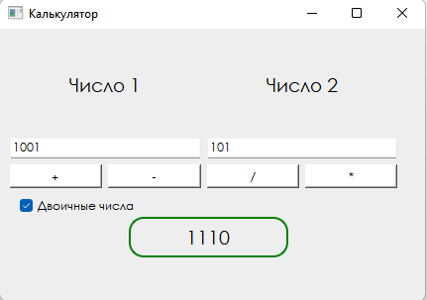

**Рис 1. Сложение двоичных чисел**

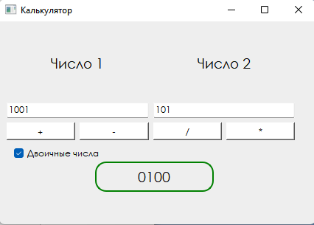

**Рис 2. Вычитание двоичных чисел**

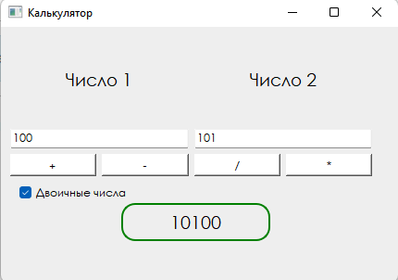

**Рис 3. Умножение двоичных чисел**

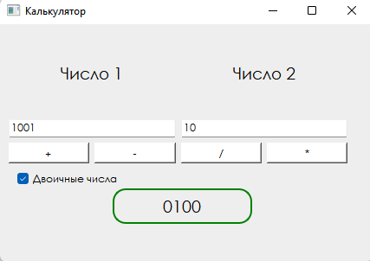

**Рис 4. Целочисленное деление двоичных чисел**